
Manual v 1.0

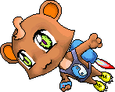

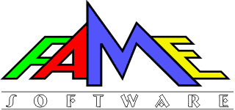
(c) 2002

Table of Contents
Table of Contents 2
Game Menus 3
Select Language Menu 3
Main Menu 3
Return to Game / Save Game & Exit / Exit to Menu 4
Save Game Menu 4
Kuzya’s Shop 5
Game Controls 5
Keys / Combos 5
Key Combos for Super Items 6
Game Items 7
Regular Items 7
Super Items 7
Game Environment 8
Credits 10

Game Menus


Select Language Menu
If you run Super Plusha in the first time, you will see “Select Language Menu”
Use arrow keys to select the language you need. You can use 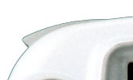 Left Shoulder Button and 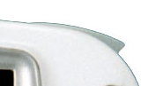 Right Shoulder Button for the first or the last language in the list. Press 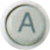 or [Start] button to select the language.

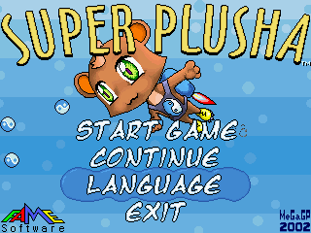
Main Menu
Use arrow keys to select the option you need. You can use Left Shoulder Button and Right Shoulder Buttons for first or the last menu item. Press or [Start] button to uses current option.

This menu item starts game from the first level.

Use this option to load previously saved games. Press or [Start] button to continue the saved game. Press 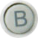 to cancel.

Use this option to select another game language

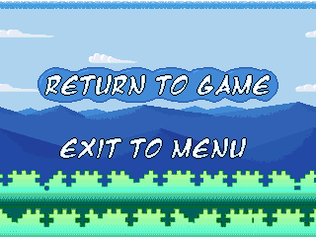
Use this option to safe reboot your GP32

Return to Game / Save Game & Exit / Exit to Menu
Use arrow keys to select the option you need. You can use Left Shoulder Button and Right Shoulder Buttons for first or the last menu item. Press button to use current option. Press or [Start] button to resume the suspended game.
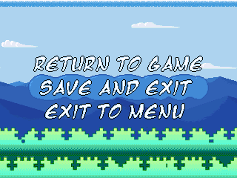
This option returns you to the suspended game.

This option enters the Save Game menu. After saving the game, you return to the main menu.
Note: You can see this option only if you have Snake’s Continue tokens.
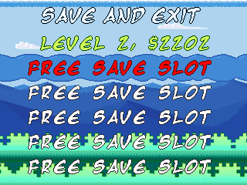
Exit to the main menu.

Save Game Menu
Use arrow keys to select any save game slot. You can use Left Shoulder Button and Right Shoulder Buttons for first or the last slot. Press or [Start] buttons to save the game. Press button to cancel.

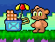
If you have bought one or more Snake’s Continue tokens then you can save your game. This option converts your super items, coins and lives into money equivalent. Therefore, you will be able to buy all you need in Kuzya’s shop.

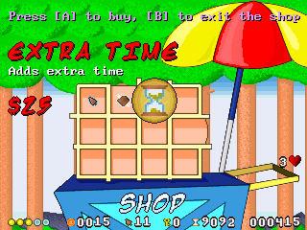
Kuzya’s Shop
Use arrow keys to select any item. Press to buy the item. Press to exit the shop. You can use Left Shoulder Button and Right Shoulder Button for the left or for the right columns of the items.
If the items name and its price are red then you do not have enough money for it. If the name of item is green then you already have it and cannot buy any more.

Game Controls

Keys / Combos
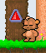
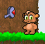
- Use arrow keys [← →] to move your character;
Press and hold [↑] to enter doors or Kuzya’s shop, to unlock key holes, to push triangle buttons or to flip switches.
Hold [↑] to look up and hold [↓] to look down.
- This button makes your character jump.
Hint: Hold to jump higher.
Hint: Push and release it fast to make a low jump.
- This button makes your character throw one of collected CONES.
Hint: Press [↑+] to throwCONES higher.
Hint: Press [↓+] to throwCONES lower. It is very useful for low enemies.
Hint: To throwCONES farther, try to RUN and to THROW at the same time. It depends of your speed and may increase the shooting range in three times. You can throwCONES even farther. Just try to run off the hill to become faster.
- [Select] This button suspends the game until you press any key.
- [Start] This button brings up “Return to game / Save game & Exit / Exit to menu” menu.
Press [Start] or to resume the suspended game.

Key Combos for Super Items
- [↑+] or - this key combo turns your SUPER JET on. You can turn it on when you lands after the jump or just falling down.
Hold to fly up.
- [↓+] or - this combo allows you crushing lower blocks with SUPER CRUSHER item.

Game Items

Regular Items
- COIN – Use it in Kuzya’s shop to buy some items.
- KEY – Allows you open key holes.
- CONE - Throw it on enemies.
- HONEY - Restores your energy. You can have up to five ENERGY points.
- EXTRA TIME - Adds extra time. You cannot accumulate extra time.
- LIFE - Adds extra life.
- SNAKE’S CONTINUE - Lets you save or continue game. After losing all lives, it allows you restart current level from the beginning.

Super Items
- SUPER POWER - Supplies power for some super items.
Note: You cannot accumulate SUPER POWER tokens.
- SUPER SHIELD - Protects you with SUPER POWER.
Note: This shield protects you from flying / moving objects such as enemies and their bullets. However, it also “protects” you from getting falling prizes (COINS, HONEY).
- SUPER LENS - Shows some secrets and hidden items.
Note: It can show you some hidden teleports or items. However, it cannot show you invisible walls and some other secrets.
- SUPER JUMP - Increases your jump height.
Note: You can buy up to two SUPER JUMP accelerators. You will find some places where “very low jumps” are the best. So SUPER JUMP might make “very low jumps” impossible to perform.
- SPIKY BOOTS - Lets you kill enemy jumping on them.
Note: You cannot kill big enemies (i.e. BOSS). You do not get a coin after killing enemies.
- SUPER CRUSHER - Crushes lower blocks after the jump.
Note: You can crush blocks with your feet. It may save your time for some secret places.
- SUPER JET - Lets you fly high with SUPER POWER.
Note: If you touch an obstacle then SUPER JET automatically turns off. You have to run it again if you need.

Game Environment
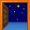
Doors – If the door is opened then it teleport you to another place. One of these doors leads you to the LEVEL BOSS.
Note: There are some hidden or invisible doors in the levels.
Check Point – Lets you start playing current level from this point (after death).
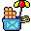
Kuzya’s Shop – You can buy there some items.
- Key Holes – Open doors, secret passages, bridges and unlock other key holes and buttons
Switches – turn on/off lifts. You can flip them many times.
- Buttons – open doors, build bridges, unlock key holes and reset other buttons.
Note: There are some invisible buttons / triggers.

Blocks – There are three kinds of blocks:
Solid block – you cannot crush such a block.
Surprise – you can get some prizes after the crushing the block
Self-destroying block – If you stand on these blocks, they do self-destroy and fall down.
Hint: You may fall blocks on your enemies’ heads.
Note: All kinds of blocks might look the same.
Lifts – There are many lifts of different size and route. Some of lifts are small and they are not so easy to use.

Spikes, icicles – You can pass these obstacles on foot. However, once jumped or fallen on the spikes you lose all of your energy.
Water, Lava– If you fall in the water or lava, you lose all of your energy at once.

Credits
Producer, Director, Lead Programmer, Scenario Writer
Mikhail Bratous

Assistant Programmer
Miguel Angel

Level Design
Mikhail Bratous

Graphic Design
Mikhail Bratous
Oleg Bronnikov
Natalia Bronnikova
Music & Sound FX
Mikhail Bratous
Soundmen, GraF (Levels Themes)
Tone (T-REX crew) (Game Over)
BOBBYB (Continue)
Warpmind de InzanE (Alien Theme)
Game Translation
Spanish: Miguel Angel
French: Stifu
Korean: Valken Lee, Rino
German: ]DC[, Raven
Italian: Francesco

FaMe Soft STAFF: Musicmen, GraF, Konstantin Chufarov, Victor Malakhov, Alexander Alyaev (Some of these people do not work with us now but we are grateful them for support).

Special Thanks To
GamePark, Aj0, Mr.Spiv, FireFly, Valken Lee, ZardosJones, _mp_, DarkFader, Stifu, and Wishmoo for support.

